Programa Radionico
Manifestor Version 1.5
It is decompressed with the Winrar Program.
Once unzipped, it goes into the Radionic Manifestor program folder.
Click on the icon, Radionic Manifestor.exe
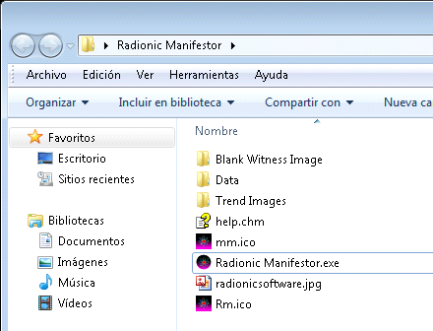
The program will be activated and this screen will appear.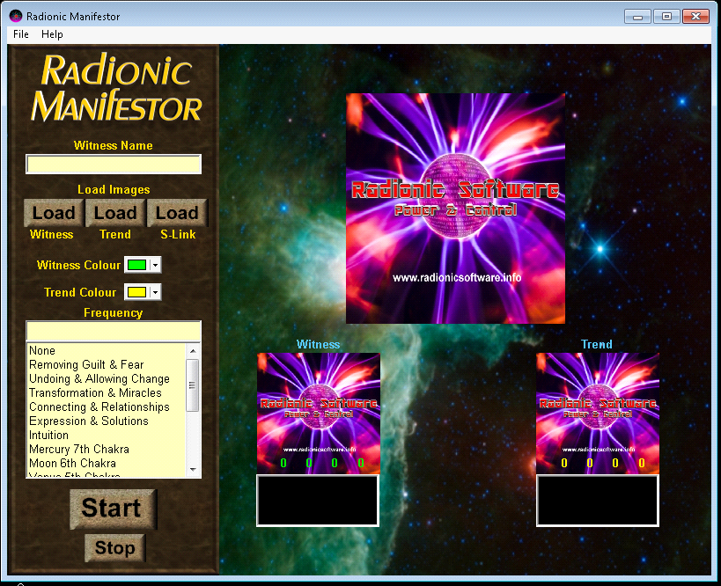
Click on, Load Witness, which means load witness. There you upload a photo of the person or place to be treated. It looks like Windows Explorer, the image can be loaded from anywhere on the PC, but generally, for more order, the photo can be kept in the Witness Image Photo Witness folder.
The photo is pressed, so that a numerical value is given.
The color is put according to what is wanted in the numbers. In Witness color and Trend color.
Color matches
White
Spirituality, cleanliness, purity, perfection, innocence, integrity, healing, freedom, opportunity, forgiveness
Black
Stability, mystery, absorbs energy
Red
Love, passion, sex, self-confidence, success, strength, creativity, persistence, energy and vitality, healing
Pink
Tenderness, sensitivity, harmony, femininity
Orange
Happiness, excitement, assertiveness, motivation, persistence, and prosperity. Orange is useful to eliminate procrastination, anxiety, stress and achieve your goals.

Yellow
Joy, joy, intellect, hope, direction, personal power, clear thinking, concentration, fruitfulness, communication
Green
Wealth, abundance, longevity, healing
blue
Communication, creativity, integrity, calm, truth, loyalty, justice, leadership, clear thinking
Indigo
Justice, wisdom, inspiration, intuition, spirituality, psychic powers, understanding, phobias, stress.
Violet or purple
Inspiration, spirituality, the sacred, selflessness, tolerance, intuition, imagination, royalty, wealth, inner peace, security, protection, creativity, freedom, psychic ability
Brown
Good health, hard work, stability, reward
Gold
Success, money, abundance, power, positivity, confidence, self-motivation, self-discipline, generosity, illustration, manifestation
Silver
Balance, harmony, change, learning, introspection, trust, wealth, secrets, hidden desires, intuition
Gray
Sadness, humility, doubt
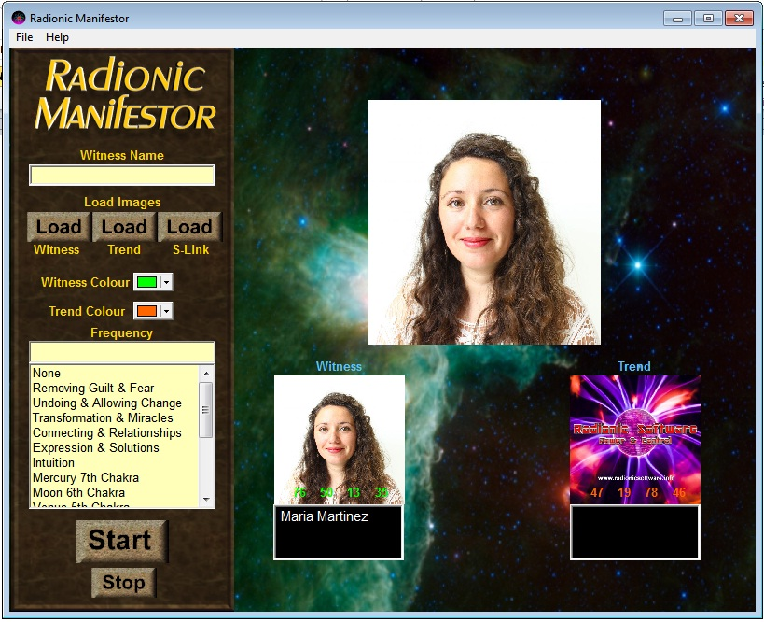
To later carry the symbol, to manifest in reality. In Load Trend, look for the symbol or in the folder Trend Images Symbol, or wherever you have it.
And you write what you want. Press on the symbol for numerical reading or radionic rhine.
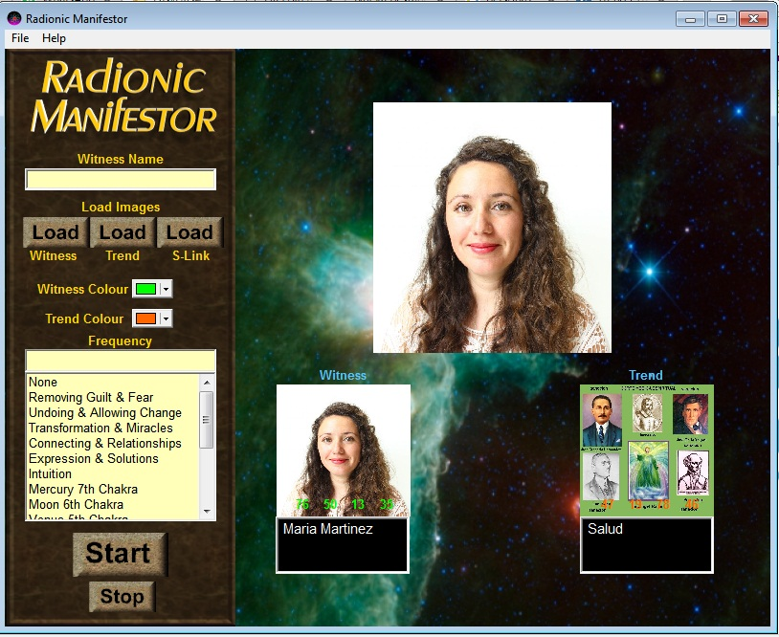
For more effect, triangulation can be used, which is related to the topic.
For that a related symbol is used, it is loaded in Load S-Link.
Related sound can be used, or not.
Or use a Windows Media recording that is repetitive. This aspect will be explained later.
Finally it is given to Start.
The program will be active now.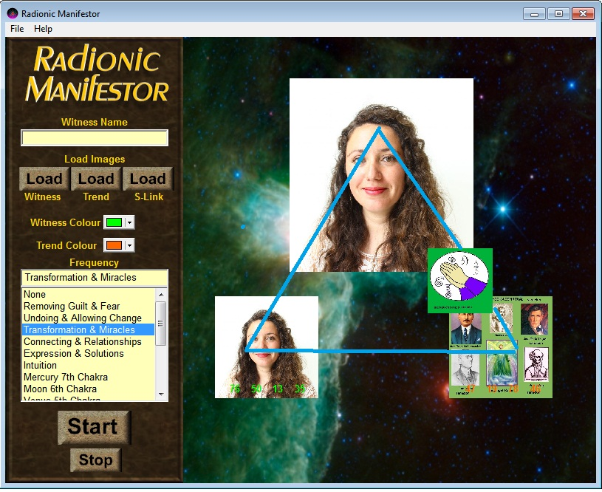
Using recordings with a PC player.
Some record an affirmation of what they want separately and place it in their Windows player, on automatic repeat, at low volume. At the same time that the program works. The repetitive affirmation also has the power to manifest itself in physical reality.
On some computers, after a while, the monitor goes black, or the screen saver is activated.
In this case, start the Windows Media player with an audio or video and put it on automatic repetition. This will make the computer stay with the monitor active. And this player minimizes it. And display the Manifestor program on the screen.
The power of this program is in its projection on the monitor. From there creation goes into space, producing the desired effects. But you want to let the monitor pay, it also works but slower.

It can be used all day and turned off at night so that the computer can rest.
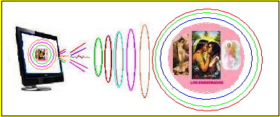
Manifestor in action.
Something else for audio or sound.
Statements that can be recorded and placed, instead of the program's audio and put on automatic repeat in Windows Media Player. At the same time as the program, it works. It is turned to low volume.
If you want to influence different people, with the same message, you will have to record an audio message for each person, concentrating each message on each person. Never use the same audio message for someone else, other than the one you focused on, when you recorded it.
Example:
Love:
If you can, you can paint, photo, draw, a romantic scene and affirmations appropriate to what you want.
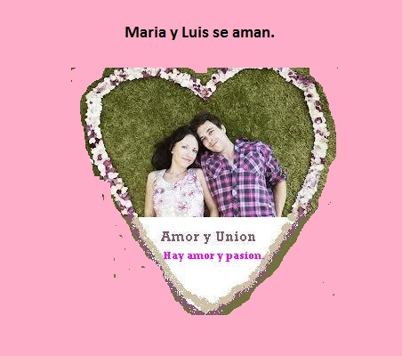
The following can be written above and below the photo or drawing of the couple.
Example:
There is love, desire and union between us.
There is forgiveness and understanding.
We love each other a lot and there is harmony.
There is peace, love and understanding.
So-and-so, he loves me and loves me madly.
So-and-so is crazy with love and desire for me.
Similar recording can also be done.
The image of love below is used as a manifestation image.
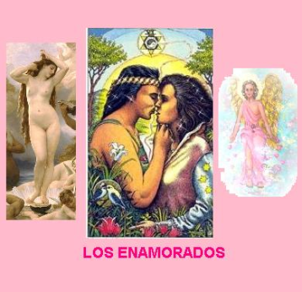
Love
Here is present, the goddess Venus or Aphrodite, the Archangel of Love, Chamuel and the image of lovers.
Winess Name, Name of the witness, the name of the couple, Example Cristina and José.
Your Manifestation, its manifestation, Example: Love and passion.

Remember to influence, not dominate. The program itself has an influence, but it depends on the free will of the person.
Well, that situation that I was commenting on, that suddenly, you notice an inner change towards a person, after a dream, or after an unimportant event, is usually due to a love spell or some form of remote mind control (the traditional way where you have to be sitting in a chair concentrating / for a long time on the woman / man you love and send her love suggestions).
This is also the way it works, the influenced person feels something similar, and this feeling comes from the subconscious mind, and it begins with a change of mind towards you, and with continued use of the program, that change of mind and that attraction of suddenly towards you, progressively gives way to love, to a point where he will not be able to live without you.
In some cases this does not happen, since there must be minimal chemistry and some affection for it to occur.
Health:
In the photo of the patient this is written above and below.
The Spiritual Medical Court, heal Luis Martínez, the Liver and any other health problem.
Winess Name, Name of the witness, in this case Luis Martínez.
Your Manifestation, your manifestation, Healing.
This image is used with the doctors of heaven.
They are the archangel Rafael, Hippocrates, Paracelsus, Dr. José Gregorio Hernández, Dr. José María Vargas and Dr. Luis Razetti.
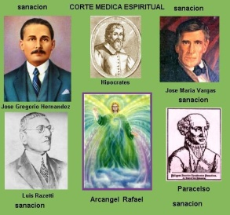
Medical Court
Wealth.
You can put the photo of the people and business and up and down you can write this or similar.
Sri Lashmi, Sri Ganesha and Sri Sarawati, give me prosperity and fortune.
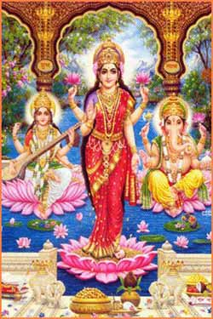
Diosa Lashmi, Ganesha y Saraswati.
Lashmi, prosper, Ganesha unblocks paths and opens them to success and prosperity, and Saraswati, gives the appropriate Wisdom to handle life.
Winess Name, Name of the witness, name of person, group or business.

More program examples.
MANIFESTOR
If you do not have a photograph of the person you want to influence, then you should make a drawing of the person, with any drawing program, or on paper and scan it later, and save it in BMP or JPG format and put it in the subdirectory of the photographs. More than a realistic drawing, it should be a symbolic drawing that represents that person. Use symbols and words in the drawing that represent that person: their profession, their character, anything that identifies them. It must be square, the photo and what you place, see example.
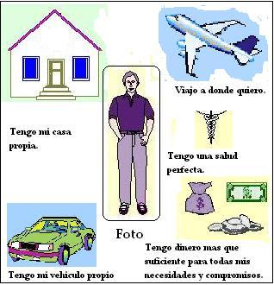
Also if you do not have the photo, you can put if possible the name and surname below the drawing.
Pre-recorded sounds. Recording sentence or using sentences or sounds, ready. If you already have the photo or drawing of that person, now you need to record the influence in audio format, saving it in a format that can be reproduced.
You already have the program, some previous recordings, but you can make new ones, if you wish. These were made with the TextAloud program.
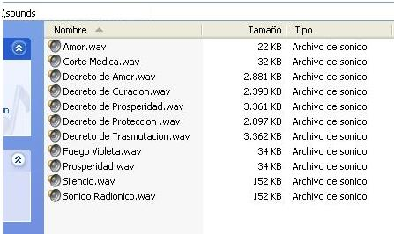

1) Increase your personal magnetism and your attractiveness towards the opposite sex.

Increase your personal magnetism and your attractiveness towards the opposite sex.
So you want the whole world to love you and have a great personal presence in the environment?
Well, the program will help you become a person of great magnetism and attractiveness.
Put your own photo !!!
In the photo you will write and recording that you do, you will say the following. "I have a great personal magnetism" "I control people with my eyes" "My voice attracts everyone" "My presence makes an impact"
If you rather want the attraction of the opposite sex, then the messages should be like this: "Women want me madly" "I have strong sexual attractiveness"
"My voice makes women fall in love" "My eyes are rays of seduction"
With the audio message you can extend yourself further: “I have a magnetic energy shell around me, all the women (or men) who pass by me feel this force and suddenly they feel a great passion and love for me. They surrender to my personal power and I control them. Every woman I look at feels my power and falls into my shield of magnetism forever feeling an overflowing passion and a crazy love for me "
The image that he will use to manifest will be that of lovers.
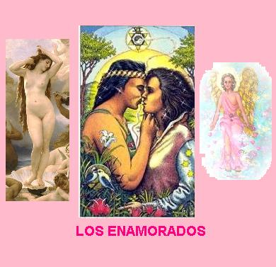
2) To receive spiritual advice.
If you are thinking a lot about something that worries you and would like to receive spiritual advice about what this electronic program will be able to help you.
In symbols the Tarot card 5 is used, the major arcana, The Hierophant or Pope.
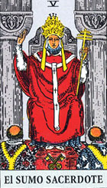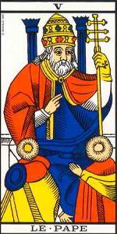

You can also use the image of a form of God, or a master of light.
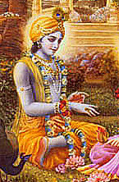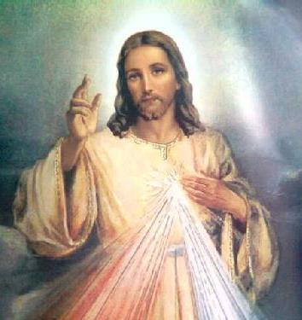
Sri Krishna Lord Jesús

I NEED SPIRITUAL ADVICE, I NEED SPIRITUAL GUIDANCE.
I need advice, about this, or that.
Audio: the same text command, but adding after doing what you need specific spiritual counseling, for example: do you need spiritual counseling for ....
You can write on the image where you want to be advised or guided.
Vibrate the important words of the audio command, especially the statement to vibrate 'I need spiritual advice'.
3) For healing
Either for your healing or for someone else. The photo of the one to be healed is placed.
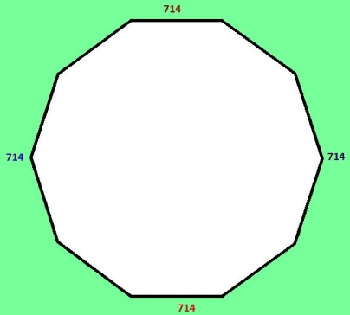
He posts messages like this, You are healthy.
You are healing from all your ailments.
It is healing from the liver, etc.
You are healthy, full of youth and vigor.
Same in the audio. The Celestial Medical Court and the Archangel Raphael are put as operators.
It is chosen in symbols, the drawing of the Archangel Raphael or the Master Hilarion.
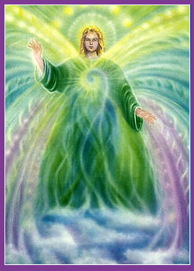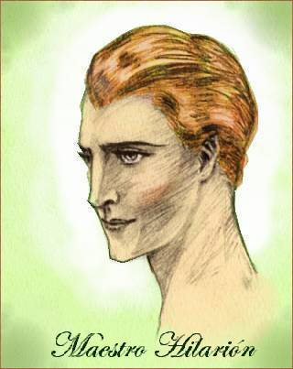
Archangel Raphael Master Hilarion
Depending on the case of the health problem, be it physical, emotional or mental, the colors, images and words of suggestion will vary.
But you can always use the Archangel Raphael who is a specialist in physical, emotional and mental health problems. The healing director of the green Healing Ray is Master Hilarion.
The most complete of the SYMBOLS in the images is that of the Medical Court, it is the most effective.
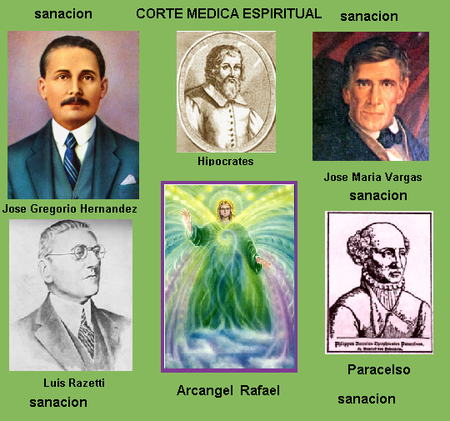
Where are the most renowned doctors, such as Hippocrates, father of medicine, Paracelsus, doctor and alchemists and others, very famous doctors.
Physical illness
For example: written and recorded messages.
Of fiscal evils. If it is the heart.
1) I have a heart that is healthy.
2) My heart and circulation are working perfectly.
3) I have peace, serenity and long life and health.
4) I have joy and prosperity.

Another organ or organs with problems.
1) The liver and pancreas are being healed.
2) The liver and pancreas work perfectly.
3) I am in perfect health.
4) I have joy, peace and prosperity.

Another example. In case of general deterioration.
1) I am in perfect health.
2) I have a feedback from all my organisms.
3) My whole organism works perfectly.
4) I have peace, harmony and health.

Emotional problems.
1) I am in peace and harmony with everyone.
2) I live fully with peace and harmony.
3) I have joy and I live with happiness.
4) I am calm and free from fear.

Joy, happiness can also be used as symbols.

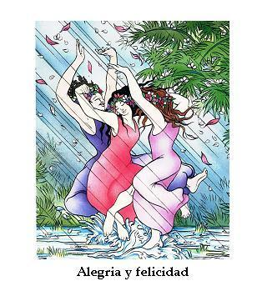
Mental problems.
1) I am in peace and harmony with everyone.
2) I live fully with peace and harmony.
3) I have joy and I live with happiness.
4) I live with simplicity and harmony.

For fertility.
In the case of people with fertility problems, these formulas can be used.
The photo of the person to be healed.
It is placed colors, green and orange.
The following sentences are made.
1) My bodies are totally healed.
2) My reproductive organs are regenerated.
3) I have my desired child.
4) I am happy and I have peace.

It is used as symbols.
In the first stage to the Archangel Raphael or the Master Hilarion and the Divine Conception of the Virgin Mary.

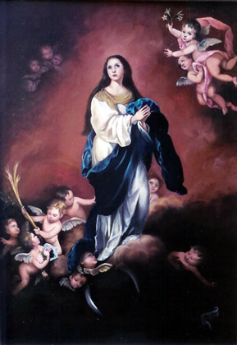

It is recommended to do 3-day sections to the Archangel Raphael, then 3 days daily, Hilarion and 1 day the Divine Conception and so on.
It is advisable to take wheat germ, which naturally has vitamin E, which helps the reproductive organs. Raw purple and red grapes and celery are cell regenerators that can be taken on an empty stomach, every day.
4) To lose weight and achieve the perfect weight.
With this program, you will achieve the perfect weight.
The photo of the person to lose weight is placed, if you have an old photo with the perfect weight, you can use it, if not, the face of the person is enough.
Sentences that can be used and recorded if you want.
1) I lose weight and achieve my perfect weight.
2) As only not necessary and balanced.
3) I am in peace, security and harmony in all.
4) I have perfect health and prosperity.

As symbols, the Sun is used and alternately the Archangel Raphael.
For example 3 days the archangel Raphael.
5) Reconciliation of couples or a reciprocated love.
Reconciliation of couples. She puts a photo of a couple and puts messages of reconciliation, union and harmonies. Sometimes we want a love to swear, with someone who does not correspond to you, in this case, in general, if you manage to suggest her, this will not last long, because it does not correspond to you in chemistry, nor is it astrological configuration.
Here an example,
There is love, desire and union between us.
There is forgiveness and understanding.
We love each other a lot and there is harmony.
There is peace, love and understanding.
It gets the same in the audio.
You can use symbols of love instead. Like these that are in the symbols folder.
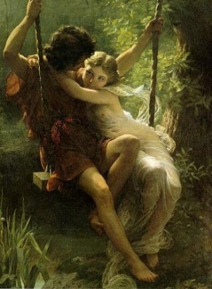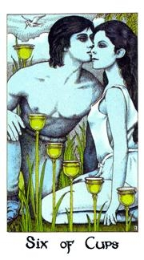
Remember to speak in the first person, and also in the present tense. Not in the future, so do not use expressions such as "I will love Pedro", but you must speak as if it were already a reality: "I love Pedro"
Now let's compose the audio message. The size of the audio message is only limited by the ram memory of your computer. In the audio message you can extend more, and it should be more or less similar to the written message, although the only rule is that the audio message should not be opposite to what you say in the written message. Remember to record the audio message at times when you feel very good about yourself, and happy, write the message on paper first, relax, try to imagine yourself with Ana, the two lovers kissing. Speak slowly and in a soft, suggestive voice.
Example of an audio message for this case: “I love Pedro with all my heart, all this time being friends, and now I realize that I cannot live without him, that my life has no meaning when he is not around me. side. When I see him appear, my heart leaps with joy and I feel happy and full of love; when he leaves my side, my heart suffers. I need to be by his side, talk to him, touch him and kiss him. I love him madly "
Also, if you are skilled with photo retouching, you can build a scene where Pedro and Ana appear hand in hand kissing and in the background a romantic park. As I said before, the subconscious is very permeable to images, so the time invested in this will be highly rewarded.
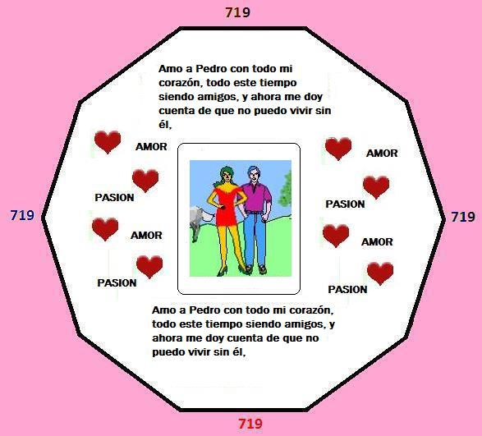

BEHAVIORAL TRICKS WHILE USING THE PROGRAM: Well, with Ana you crossed the fine line that separates simple friendship from deep friendship. In normal cases, when you become close friends with a woman or man, it is practically impossible since there may be a love relationship between the two in the future, since that deep friendship will prevent both of you. I am going to give you some guidelines for behavior while executing this influence with the program. On those days while you influence Ana, try to avoid her as much as you can, stay away from her, don't hang out, and be elusive on the phone. Why, you ask?
To increase Ana's need to see you. She will be being strongly influenced by Tele Hypnosis to love and need you, so she must see that she cannot live without you, and if you do not stay and avoid her, her need to see you will increase. Do not abuse either, you simply have to avoid it for the necessary time until it is "ready to eat", when that moment arrives, in a few weeks of influence, stay with it and ... all done !!!

6) You love a girl / boy, but you hardly know her and / or have talked to her / him.
You love a girl / boy, but you hardly know her and / or have talked to her / him.
In this case, Ana is not your friend, you may only see her in some classes at the university, or she works in the same place as you, but you have never spoken with her or very little.
The procedure to follow in this case is the same as that described in case 1, although you must try by all means that there is a link between you and her, be it a common friend, a co-worker, etc. This nexus of union is very given that it will be the communication channel between you and her when she is influenced and is wanting with all her heart to go out with you. If there is no person who can serve as a connecting link, you will have to previously influence a friend of hers to be receptive to you and become your friend as well.
The liaison person is very important if Ana is shy. If you are not shy, instead of the liaison person, after influencing her, go and talk directly to her very politely and propose to meet.
If you are both shy and there is no liaison person, then, after influencing her to love you, you will have to influence her a few sessions to force her to talk to you and give her the necessary will to dare to do so (using red colors, a darker one and another clearer, imperative style and high frequency).
7) To choose between alternatives.
There are situations in life, when you have to choose between various alternatives and you do not know which alternative in particular, you have to choose. You feel insecure and hesitant of what choice to do, so you need help to reflect and consider all possible alternatives and make a good choice among all the offered alternatives.
This electronic magic spell is based on one of the main arcana of the Tarot, specifically the card number 6, the arcana of The Lovers.
It is a growth of free configuration.
Audio: Audio: first vibrate the word 'discrimination' and after registering something like this: "My ability to choose and make good choices when there are different alternatives increases every day, I am able to reflect and all the alternatives that are offered and I am able to choose correctly "
Vibrate the important words of the audio command.
Gemini Astrological sign related to this tarot: Gemini,
Optional procedures: Audio records Make a small visualization priority to record the audio and visualize your remote control in situations in which you have to choose between different alternatives and you are able to reflect, meditate and reflect on each alternative and finally choose a good alternative .

8) For liberation from spiritual evils.

This programming has the virtue of freeing the person from bad energies, which are of various possible origins.
1) Own energies caused by your mind and emotions, whether by fixed ideas, hobbies, fears, these crystallize into parasitic energies in the person.
2) Emotional and mental energies, caused by anger, envy and slander of other people or own.
3) By spells and negative magic of any kind, purposely done to harm the person, be it of any kind.
Place the photo of the person to help, be it your own or that of another person or a symbolic drawing of the person.
It is written as a statement and recorded as appropriate.
In case 1 and 2
You can use something like this or similar, depending on the phobia or fears.
I am fine, free from all fear.
I have full confidence, in what I do.
I live a life in harmony
Fire dissolves all evil that affects me.
Case 3 About spiritual evils.
a) I am healthy and strong.
b) I am successful in everything I do.
c) Fire dissolves all spiritual evil
d) I am free from all evil.
Archangel Michael and the spiritual Protectors of Light are set as operators.
Several options, in mild cases the violet fire, or the Archangel Zadkiel and in medium cases the Archangel Michael and in severe cases, the Sun.
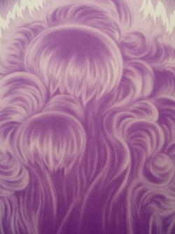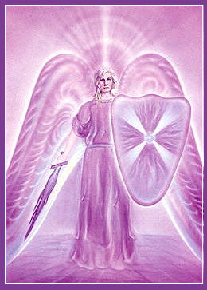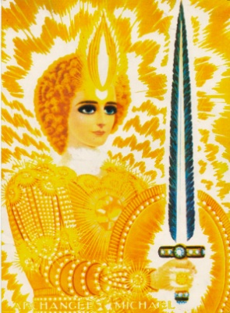
Violet Fire Archangel Zadkiel Archangel Michael Sun.
Violet fire is disinfectant and purifier.
Also in extreme case, the archangel Michael liberates you and eliminates spiritual evils.
For more power the photo of the Sun.
In very extreme cases the symbol of the Sun, which attracts solar rays, with its potential burns all spiritual evil and will also give vitality to the person.
9) For cases of extreme spiritual evils.
There are spiritual evils that cause a lot of damage and require more powerful programs.
In this case, your photo is also used with special protections like the one shown below.
You can take this example and replace it with your name and photo.

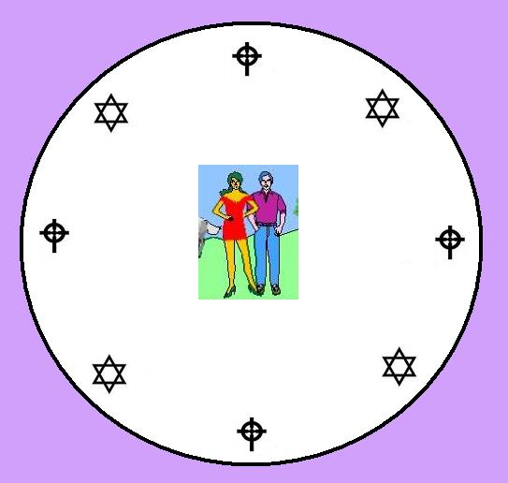

You can take this example and replace it with your name and photo.

Here's another example:
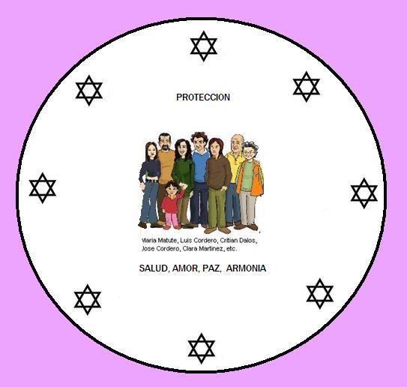
In the case of a protection family group:
It can be used, circles with a six-pointed star, which represent the Solar force and the balance of the two triangles between loops, the balance between the material and spiritual. You can also use the combination of crosses and stars. They are all very effective.
In the case of a company:
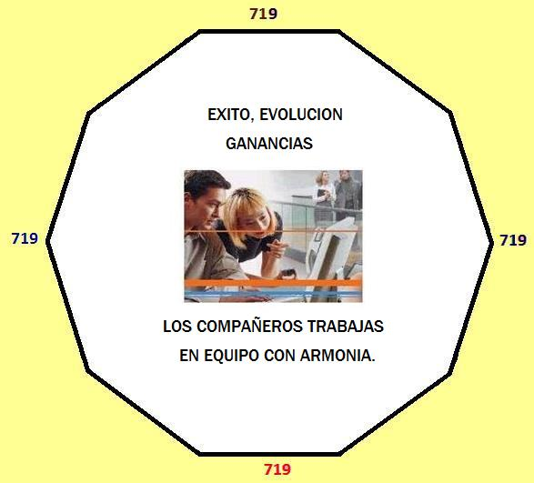

YELLOW FOR MATERIAL ACHIEVEMENTS.
It is possible in the case of the family and company, requests can be made as in example 1 or 2. For a more complete work, and everything will be written in the plural, for example the cleaning of all or of so-and-so, zutano, is requested. etc.
After designing the photo with requests and other details, the radionic index, the RIN, is done, and ready, it is programmed in the program

JUDGMENTS
I AM HEALTHY AND STRONG.
I AM SUCCESSFUL IN EVERYTHING I DO.
THE FIRE SUN, DISSOLVES ALL SPIRITUAL EVIL
I AM FREE FROM ALL SPIRITUAL EVIL.

As Symbols, to use or images, you choose these 2 an initial that is the Violet Sun Mandala.
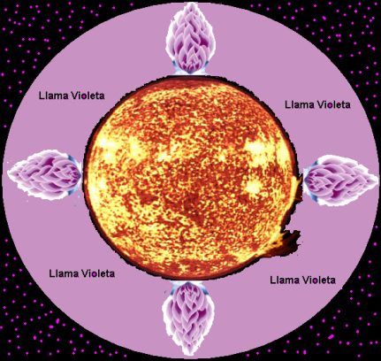

This is the Mandala, Violet Sun, which has, the power of the Sun's fire, combined with the powerful violet fire, it transmutes all spiritual evil.
Archangel Michael can be used alternately.
10) Telemedicine for positive thoughts.
This setting has to be helpful for positive thoughts. If you really have negative thoughts and feelings and you want to eliminate them from your account, use this setting to transmute negative thoughts into positive ones.
The photo of the person to help is used, be it that of one or another person.
Symbol: use an image of the sun, photo of the Sun.
"Light", "Luminous thoughts", "positive thoughts" and "My mind shines"
Another example
1) I HAVE HAPPINESS AND PEACE.
2) I HAVE POSITIVE THOUGHTS.
3) POSITIVE THOUGHTS COME TO ME.
4) I HAVE PEACE AND LOVE IN MY LIFE.
Audio: similar Texts. Audio: similar to text commands.
Note on Audio: record it at a time when you feel very good and happy.
Optional: record the command audio on the day and planetary time of the sun, but this is optional, the most important thing is that you will be registered in a good emotional state.
11) Another formula for aura cleansing.
When you feel that your mind and psychic body is "cloudy", or you feel that your aura has been badly permeated with influences, emotions and thoughts, and you realize that they are caused by external energies, it is time for cleansing. Laura's.
First, you need a full body photo, have a digital camera or normal camera use and then scan the image with a scanner, and better yet, create a single image with 2 photos, the front body image and the Rear body image, join Using photo editing software and create a unique "holistic" full photo of yourself. For a complete aura cleaning the usual passport photo is not the most suitable.
-Symbol: - Symbol: an image of the sun, or the astrological symbol of the sun, or the other alternative is to use a photograph of pure unrefined sea salt, which, as you probably know has psychic cleansing properties.
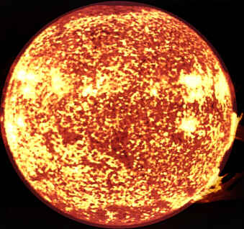
Photo of the Sun is on the program
Texts: Text commands: "aura cleansing", "light", "purity", "aura cleansing"
Audios: Audios: save the Audios only with the keywords in the text commands, focus on the meaning of each word doing a short meditation on the meaning of each word and then pronounce.
This aura cleansing setup usually works well and is quick to produce results; you should feel better, with a clear mind, and have no negative feelings or emotions.
12) Attract prosperity and wealth, of person or business. Photography: your own photo, also the person to help, or place, business.

You can make a composition of the prosperous person, or the prosperous business.
It is used in a yellow or green decagon in some cases.

I HAVE THRIVING IN ALL THINGS.
GOOD LUCK FOLLOWS ME WHEREVER I GO
I AM A SUCCESSFUL, I HAVE PEACE AND LOVE.
I AM A HAPPY AND HAPPY PERSON.
Audio: Audio: vibrate the word prosperity, you have to vibrate the pronunciation, and not just pronounce.
Symbol: Symbol: astrological symbol of Jupiter or the photo of Jupiter.
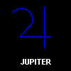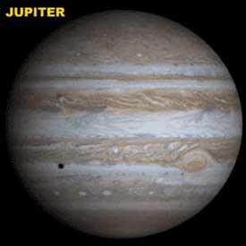
Symbol of Jupiter Photo of Jupiter
If you prefer, you can include a more focused audio command for your specific case.
You can also use deities of prosperity, If it is Ghanaian to unlock and activate the paths of prosperity and projects or Goddess Lashmi with Ganesha and Saraswati, for prosperity.
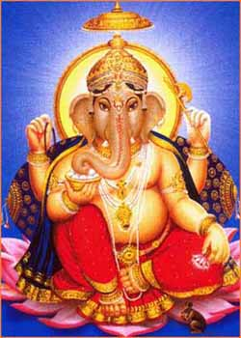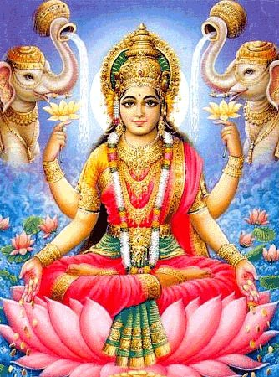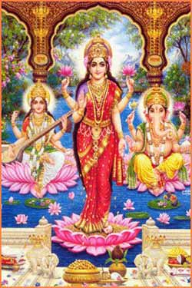
Ganesha Lashmi Combined the most effective.

-Enable. - Enable the Jupiter planet empowerment and frequency multiplier.
NOTES: Preferably do it when the moon is waxing, from new moon to full moon.

13) Electronic magic spell to help overcome shyness.
The photo of who wants to be helped is used.
If you are a shy person, who is very shy and very insecure and you would like to overcome your shyness and emotional insecurity, this electronic magic spell can help you increase your inner security and greater confidence of your abilities.

This electronic magic spell that will help you overcome shyness is based on one of the main arcana of the Tarot, specifically the card number 4, the arcana of The Emperor.
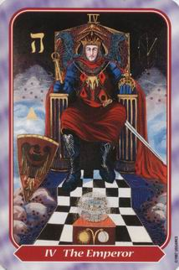
Texts: Text commands: these four text commands:
1) I have confidence in myself.
2) I have full confidence in myself.
3) I have control over myself.
4) I am sociable and friendly person
Audio: similar to the audio command, record four keywords from the text commands, vibrating instead of just speaking. You have to also use the alpha pulse, mix and paste several times throughout the entire duration of the audio command.
Aries Astrological sign related to this tarot: Aries
Audio records on the planetary command preferable day and time from Mars, for example, a Tuesday just after sunrise. Preferable, crescent moon.
Suggestions prior to recording the command audio, make a small visualization, visualize that you have a high inner emotional security, that you feel confident in your abilities, visualize that you have a great confidence in yourself and are able to speak with people with confidence AND naturalness.
Visualize that they have an inner security that is reflected security and, therefore, their social behavior is natural and that they are capable of having a normal social life.
14) For the performance of studies of any kind.
Whether for studies of any level, primary, intermediate or higher. Language study, etc.
The photo of the person to influence is used, be it their own or someone else's.
The image of the Master Hilarion or the Archangel Raphael will be used. That they work with the force of the intelligence of Mercury. And also the cards of the Priestess, and the arcanum 14 Temperance.
Each of them would be used alternately. The Priestess, gives memory and assimilate the hidden, of the studied. Temperance, intuition and experience.
You can put suggestions like these.
1) I am a smart person.
2) I easily assimilate what I study.
3) I have a good understanding of mathematics, etc.
4) I learn and remember what I have studied.
For languages ​​it will be similar, but focused on the idea, of assimilation of the language.
1) I have an easy assimilation of English.
2) I easily learn the language.
3) I understand the conversation and remember words.
4) If I understand the English language easily.
So in the recording.
15) To influence another to treat you well. Boss, etc.
If a person you treat is your boss or partner, they treat you not properly.
A photo of one is taken.
Suggestions like these are written and recorded.
1) EVERYONE ESTEEMS ME AND TREATS ME WELL.
2) THERE IS HARMONY, IN MY WORKPLACE.
3) THERE IS PEACE AND FELLOWSHIP IN MY WORK.
4) MY BOSS RESPECTS AND TREATS ME RIGHT.

It is used as a symbol, the image of the Archangel Michael, which will clean and harmonize the environment.
16) Development of courage or being more determined.
With your photo or whoever wants to help.
Tarot or the King of wands for men or Queen of wands or the Emperor, letter 4 Major.
Texts: I am determined or I decide, I am brave, the willpower, the resolution, etc.

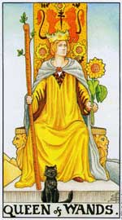
Queen and King of Wands
Audio: similar to text commands. Try to record the command audio with a feeling of will, visualize that you are very confident and decisive, and then when you feel determined for a while, record the command audio.
17) Be your child or a rebellious boy or girl and to be applied and studious.
The image that we want to influence is used. In some cases you can put the image of the father or mother with the child, in harmony.
Sentences to Write and record.
This is an example, which you can always modify according to the case and what you think best to indicate.

1) YOU ARE A HARMONIOUS CHILD OR YOUNG MAN.
2) YOU AVOID BAD COMPANIES.
3) THERE IS A GREAT COMPRESSION BETWEEN YOU AND X.
4) YOU HAVE ORDER AND HARMONY WITH EVERYONE.
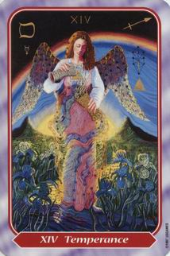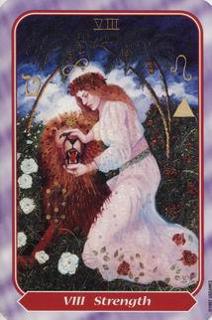
Another example to be a model person.
1) YOU ARE A STUDIOUS CHILD (OR A YOUNG MAN).
2) YOU ARE A CHILD (OR A YOUNG MAN) EXEMPLARY, HARMONIOUS.
3) WHAT YOU STUDY, YOU LEARN WITH EASE.
4) YOU ARE AN EDUCATED AND RESPECTFUL CHILD.
You can use the Symbol of Temperance, tarot 14 and Strength, or number 8, which combine one in some sections and another in other sections. Which is for balance, to give virtues, peace, harmony, good sense. Oh you can use the symbol of the Sun. The card of strength indicates balanced mastery of the passions, self control. You can use this version or any other version of your liking.

18) In the same case of an adult who leads a disorderly life without control.
The image that we want to influence is used. In some cases the image of the person with problems can be put.
Sentences to Write and record.
This is an example, which you can always modify according to the case and what you think best to indicate.
1) YOU ARE A HARMONIOUS AND BALANCED PERSON.
2) YOU AVOID BAD COMPANIES.
3) YOU RESPECT AND AVOID PROBLEMS.
4) YOU HAVE ORDER AND HARMONY WITH EVERYONE.
Another example to be a model person.
1) YOU ARE A BALANCED PERSON.
2) YOU ARE AN EXEMPLARY AND HARMONIOUS PERSON.
3) YOU LEAD AN ORDERLY AND HONEST LIFE.
4) YOU ARE EDUCATED AND RESPECTFUL.
You can use the Symbol of Temperance, tarot 14 and Strength, or number 8, which combine one in some sections and another in other sections. Which is for balance, to give virtues, peace, harmony, good sense. Oh you can use the symbol of the Sun. The card of strength indicates balanced mastery of the passions, self control. You can use this version or any other version of your liking.

19) People with vices of tobacco, alcohol, etc.
The image that we want to influence is used. In some cases the image of the person with problems can be put.
Sentences to Write and record.
This is an example, which you can always modify according to the case and what you think best to indicate.
1) YOU ARE A CONTROLLED AND BALANCED PERSON.
2) YOU AVOID BAD COMPANIES.
3) YOU AVOID ALL VICES OF ANY KIND.
4) YOU HAVE ORDER AND HARMONY WITH EVERYONE.
You can use the Symbol of Temperance, tarot 14 and Strength, or number 8, which combine one in some sections and another in other sections. Which is for balance, to give virtues, peace, harmony, good sense. Or you can use the symbol of the Sun. The card of strength, indicates balanced mastery of the passions, self control. You can use this version or any other version of your liking.
20) Speaking in public.
The photograph of the person who wants to help is used, be it that of one or another person.
If you need to conquer the fear of public speaking, that you feel terribly nervous when you have to speak in public, and you are probably also very shy and shy, this electronic magic spell for could help a lot to conquer your fear of speaking in public, and feel more confident and secure when you need to speak to a group of people.
First of all, we take into account that it is normal for most people to feel some fear about public speaking, however, a shy and shy person can have a really bad time public speaking, or just imagine or think about Public speaking It can make a shy person feel really nervous. The key is also confidence and inner security, in order to increase your self-esteem it will also help you to stop or reduce the fear of public speaking.
The next is to write the electronic part of the program.
This electronic magic spell could help you in both goals: improving your internal security, and being more aware of your own internal abilities and skills, and it will also help you overcome your fear of public speaking.
This electronic magic spell is based on one of the main arcana of the Tarot, specifically the number of the card, the arcana of The Chariot or the Chariot.
Here are the settings for this electronic magic spell to help you increase your inner security and confidence and help you suspend your fear of public speaking:
Symbol: Arcana Tarot of The Chariot, or the Chariot.
Texts: Text commands: confidence, with the confidence of speaking in public.
Audio: Something like 'I speak in public with confidence and inner security I feel absolutely relaxed and confident when I speak in public "
Vibrate the important words of the audio command.
Cancer Astrological sign related to this tarot: Cancer
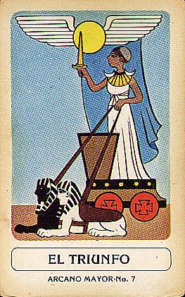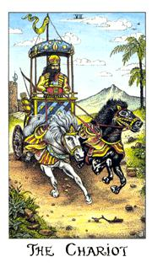

Optional procedures:
Record the preferred audio command on the planetary day and time of the Moon, for example, a Monday after sunrise. Preferable, crescent moon.
Before recording the command audio, make a small visualization visualize yourself speaking in public to a group of people and you feel absolutely relaxed and confident, visualize that you speak very well, with a good modulation of your voice and awareness of your internal security AND aware of its capabilities.
21) To improve leadership ability.
The configuration, in order to improve leadership skills, makes use of a major arcana tarot, specifically the number 4, arcana of The Emperor. This setting is used to improve Your leadership skills.
You use your own photo or that of the person you want to help.
Symbol: Symbol: Tarot great arcana of the Emperor.
Text commands: these four text commands:
I AM A LEADER AND I HAVE A LEADERSHIP.
PEOPLE RESPECT ME AND FOLLOW ME.
I MAINTAIN ORDER AND RESPECT.
I AM RESPECTED AND OBEYED.
Audio: similar to Audio, except for the 4 keywords in the text commands. You have to also use the alpha pulse, mix and paste several times throughout the entire duration of the audio command.
Aries Astrological sign related to this tarot: Aries.
Optional procedures: Save the audio on the Mars day and time command, for example, on a Tuesday just after sunrise. Preferable crescent moon.
It is suggested that before recording the command audio, that you do a small visualization, visualize that you have a high leadership ability, that you are able to manage a team successfully and that everyone respects and admires your resolve and courage to make decisions. and also, His ability to rule the team.
22) To sleep well.
With the photo of the person you want to help, be it your own or another.
If you generally have trouble sleeping well, you spend a lot of time in bed before falling asleep, you tend to be preoccupied with everyday things and cannot fall asleep easily, this electronic magic spell might help you.
This electronic magic spell is based on the arcana of the tarot 2 the Priestess, and that helps you relax the body and the mind are especially useful for the nights.
The settings of this electronic magic spell are as follows:
Symbol: Arcanum Tarot 2, the Priestess.

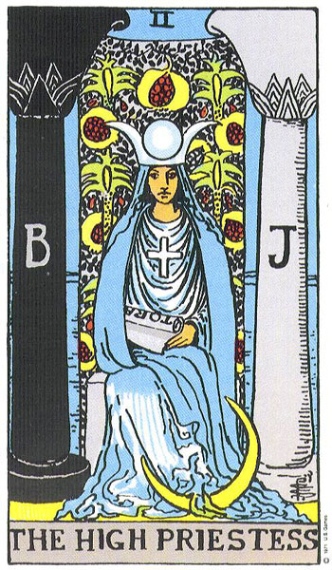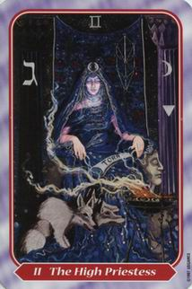

Texts: Text commands: these four text commands:

I'M RELAXED AND CALM
I sleep peacefully
I'M HAPPY AND I SLEEP DEEP.
I SLEEP SEVERELY.
Audio: similar to the audio command.
Optional procedures: Save the audio command preferable in the day and planetary hour of the Moon, it is preferable to save it on a planet instead of the night time of the day.
It is suggested that before recording the command audio, that you do a small visualization, visualize that you feel absolutely relaxed, the silence surrounds you, we feel a great relax in the body and mind.
23) To increase popularity or sociability:
With the photo of one, or of the person who wants to help.
Symbol to use: The Empress.
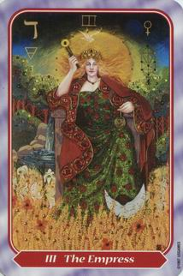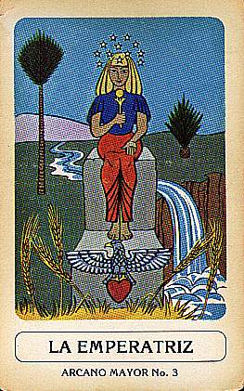
The Empress.
Text commands: these four text commands:
Here is a suggestion that can be modified to your liking.
I AM A SOCIABLE PERSON.
I LIKE TO TREAT PEOPLE AND THEY LOVE ME.
I LIKE PEOPLE AND I LOVE THEM.
I HAVE A GOOD SOCIAL LIFE.

Another example:
I AM A FRIENDLY AND SOCIABLE PERSON.
I FALLEN WELL TO THE PEOPLE.
I MAKE AN EXCELLENT SOCIAL LIFE.
I MAKE EXCELLENT FRIENDSHIPS.
With this electronic magic spell, you will allow the empowerment of the planet Venus and frequency multiplier.
24) Increase physical strength or vitality.
This is a free setup, using electronic magic, to increase your strength.
It is about electronic magic, since they are applied to you, your own image, or to another person the image of that person.
These adjustments in the symbols, with the major arcana of the Force and can be varied with the Sun in photography. Three sections the Force and one the Sun and so on.
The force
Symbol: the major arcana tarot of the Force. Commands text:
I HAVE A LOT OF STRENGTH AND VIGOR.
I AM VERY STRONG PHYSICALLY.
I HAVE A LOT OF STRENGTH AND VITALITY.
I HAVE A LOT OF PHYSICAL STRENGTH.

Audio: - Audio: you can choose to use keywords from the text commands, which is pronounced with a short meditation on what each word means to you.
Try to record the audio with a powerful voice command, before recording the command audio, try to evoke in your mind moments in your life that you felt very powerful and that you felt an inner strength that surprised you. Evoke those moments and try to awaken the same feeling of strength again, and when they have been achieved, record the command audio.
Tip: Record the audio and run this setup command for the first time on a Sunday immediately after sunrise.

25) Electronic Magic to save your marriage: Heal the spiritual wounds of your love affair or a love affair.

The goal of this electronic love magic, heal the spiritual wounds of your love relationship.
The photo of the two of them is used together, if possible it turns pink, in case, even with hearts, floating on the edges and put words like, peace, love, union, forgiveness, compression.
Symbol: Archangel Chamuel, who is the archangel of love.
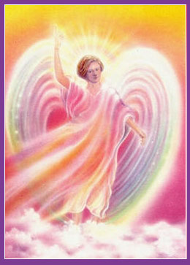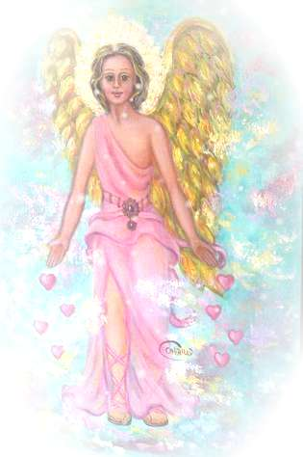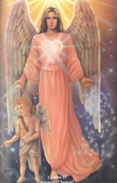

The following sentence or similar is put, written and recorded.
You can mix the audio with a love song that unites and harmonizes.

THERE IS PEACE, COMPRESSION AND UNION.
THERE IS RESPECT AND FORGIVENESS.
THERE IS LOVE AND HARMONY BETWEEN US.
WE SUPPORT EACH OTHER.

26) Unstable, changing people, so that they have firmness, solidity, floor.
The image of the person is used, it can be put around the image, solidity, stability, firmness, balance.
It can be used, the King or the Golden Queen.
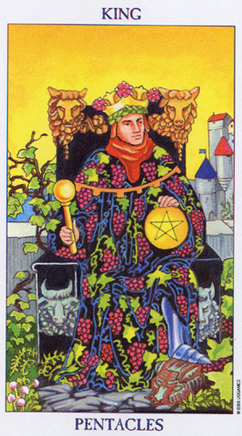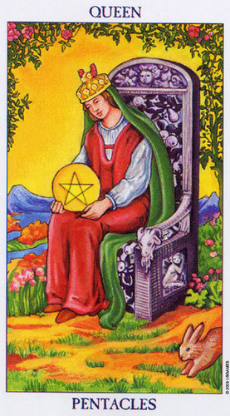
Sentences like these will be put:
I AM A STABLE PERSON.
I HAVE TRANQUILITY AND BALANCE.
I HAVE SERENITY AND CLARITY IN THINGS.
I AM IN PEACE AND HARMONY.
27) Drive away an annoying or negative person.

Your photo of the person or symbolic drawing is used, which can be done by hand, concentrating, on the annoying person and then scanned, said image and placed in the corresponding folder.
The following commands are placed:
SAN BENITO, REMOVE FULANO FROM SUCH OF MY LIFE.
SAN ALEJO, REMOVE FULANO FROM SUCH OF MY LIFE.
SAN BENITO, REMOVE FULANO FROM SUCH OF MY LIFE.
SAN ALEJO, REMOVE FULANO FROM SUCH OF MY LIFE.
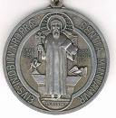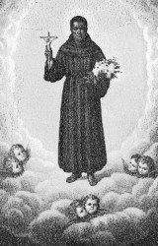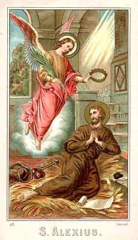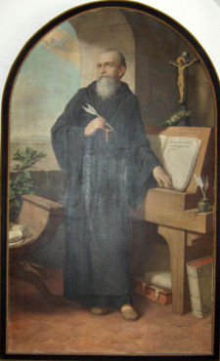

Saint Benedict Medal Saint Benedict of Palermo Saint Alejo Saint Benedict Abbot.

28) Protection in the street and dangers.
In case of dangers, or threats.
The photo of the person to be protected, be it yours or the other person.
Symbol to use San Miguel.
THE DIVINE POWER PROTECTS ME.
THE ARCHANGEL MIGUEL PROTECTS ME.
I AM FREE FROM ALL DANGERS.
I AM INVISIBLE AND INVINCIBLE IN THE FACE OF DANGER.

29) For lucid dreams.

Your photo is placed.
Symbol: The priestess or arcanum 2 of the tarot.
Saint Benedict Medal Saint Benedict of Palermo Saint Alejo Saint Benedict Abbot.

28) Protection in the street and dangers.
In case of dangers, or threats.
The photo of the person to be protected, be it yours or the other person.
Symbol to use San Miguel
THE DIVINE POWER PROTECTS ME.
THE ARCHANGEL MIGUEL PROTECTS ME.
I AM FREE FROM ALL DANGERS.
I AM INVISIBLE AND INVINCIBLE IN THE FACE OF DANGER.

29) For lucid dreams.
Your photo is placed.
Symbol: The priestess or arcanum 2 of the tarot.

. 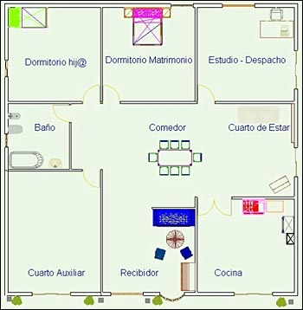

Light violet colors are used with darker violet.
The Violet Sun mandala is used in the program.
It is placed in the decrees:
THE VIOLET SUN TRANSMUITS THIS PLACE.
ALL SPIRITUAL EVIL IS DISSOLVED.
ALL BAD ENERGIES DISSOLVES.
WE ARE FREE FROM EVIL.

31) Program to improve plantings and ward off pests and parasites.

You take photos of the place, you put the address of the place.
The purple sun sets
You write decrees like this:
CROPS GROW IN HARMONY.
THE CROPS ARE FREE OF HASSLE.
CROPS THRIVE.
EVERYTHING IS GOOD IN THE CROP.

