Programa Radiónico. Mini Manifestor

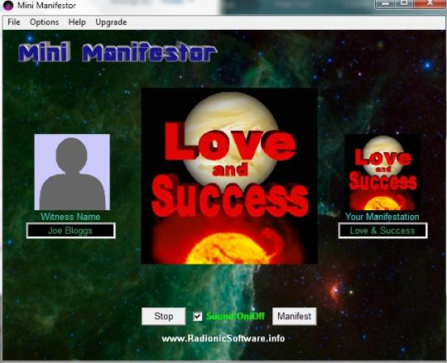
Mini Manifestor description:
Mini Manifestor application offers users a radionics device simulator, based on the concept of radionics. This "science" revolves around the idea of emanation of energy can be transmitted remotely using "specific frequencies" to stimulate the body and mind. As well as TV and radio waves also projecting invisible space.
This software is especially helpful. Radionics for its function, applying a sequence of image and text, accompanied by an optional zoom, recorded statements in some cases, to meet the desire you want.
Manifesting Mini is designed exclusively to assist in manifesting your dreams and desires through the principles of radionics. If you hope and a place to start anything, if possible. Mini manifestador is simple and basic. When you are trying to manifest something in your life, the last thing you need is this stressed, because the software program does it for you.
The program compressed, decompressed with Winrar.
If not there, you get on the Internet.
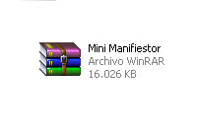
Here where you can download Winrar.
http://www.winrar.es/descargas
See next page

In extract, place it where you want.

After unzipping the program, and in the program folder is activated by pressing 2 times the Mini Manifestor icon.
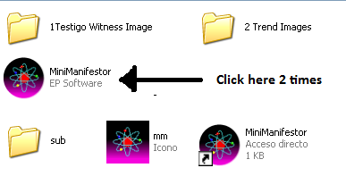
You will leave the screen.
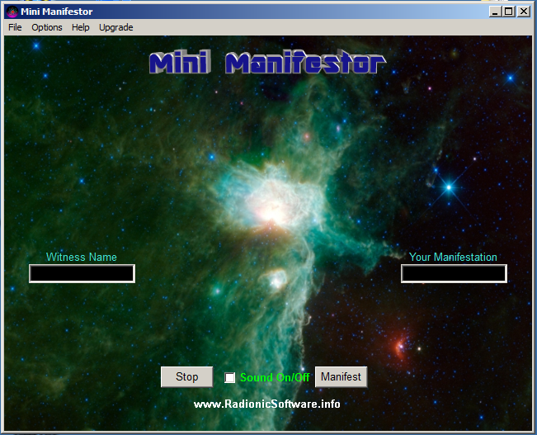

For programs you do the following.
It is brown with the mouse, up File.
.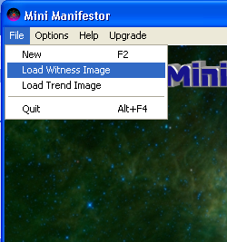

Witness Image Load means, load the image of the witness. To choose the image witness, whom I influence. Previously there should be, a photo of what you want to be influenced, helped, if couple the two together, it can be a group or a place. Always the file, such as those in the folder, 1Testigo Witness Image.
Within the image, you can also write what you want to achieve. For example, Louis loves me dearly.
Where to put the photos or images to influence
.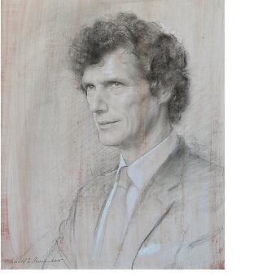
Here some example. You can write in the pictures, the wishes you want to be made.
.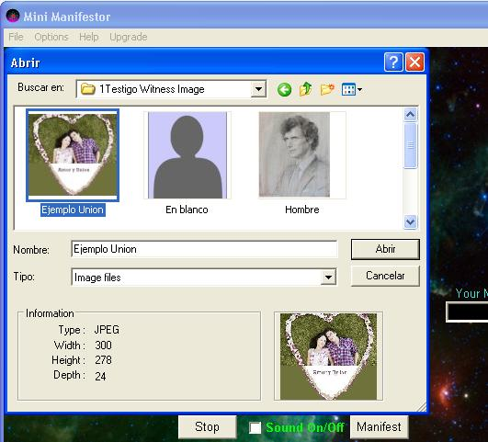
Choose witness, or image you want to influence.
Then select Abri it goes well.
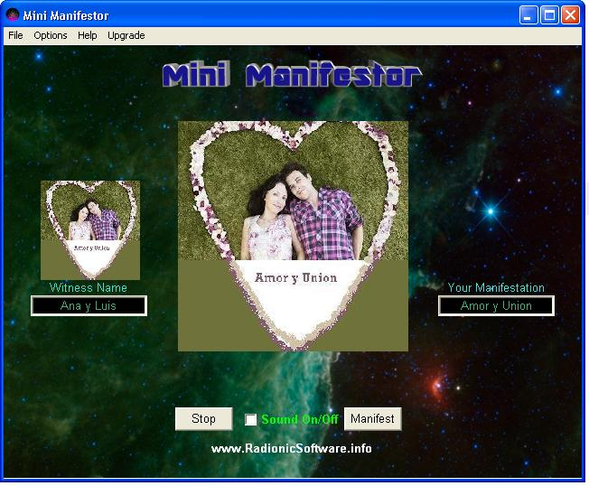
Then you need to place the image of what you want to manifest in reality.
Do the same on File.
He goes into the folder 2 Protest Trend Images
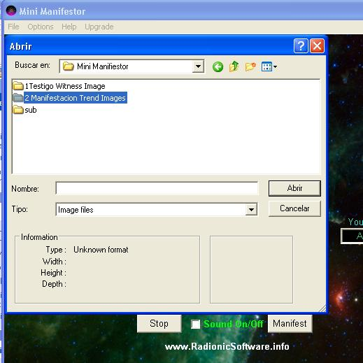

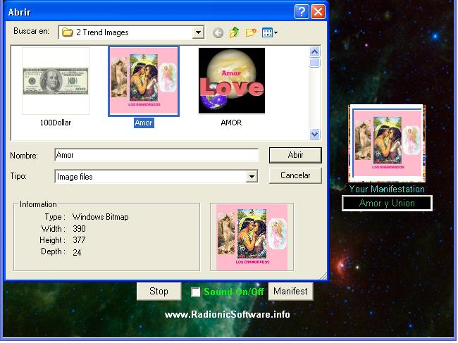
Choose as you want, as you want, to give. Here some pictures of the program.
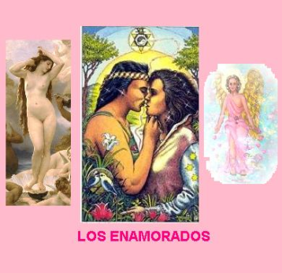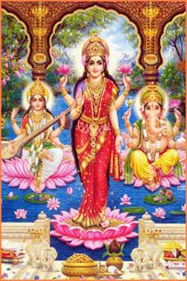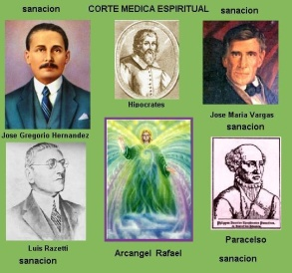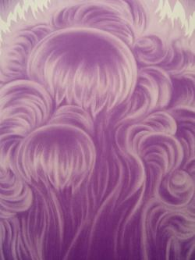
Love Wealth health Violet Fire

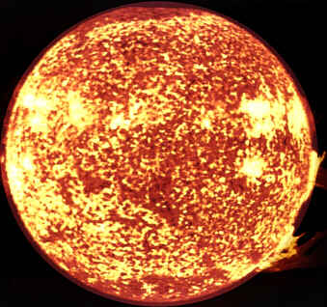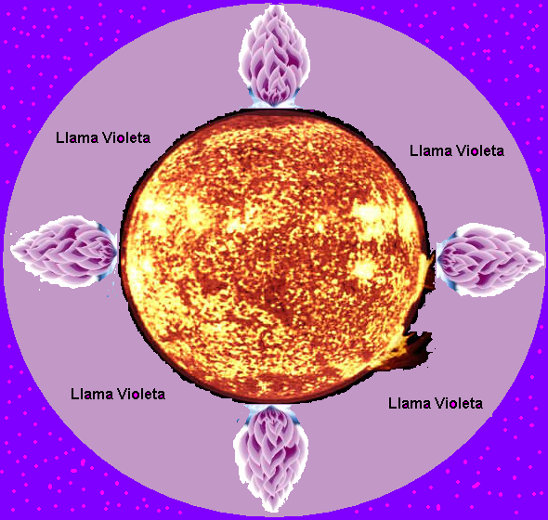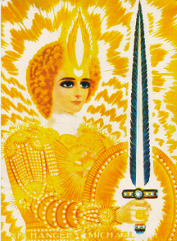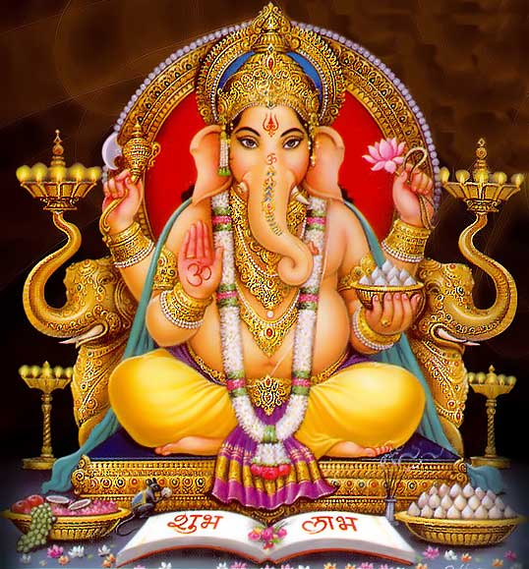
Sol Vitality Sun transmuting San Miguel Ganesha

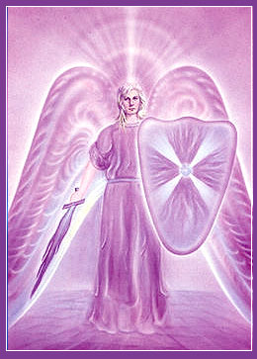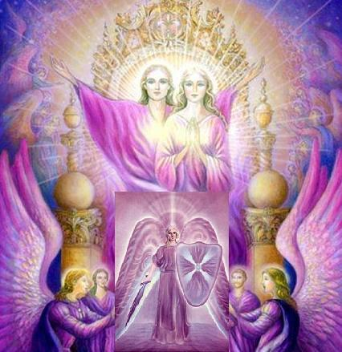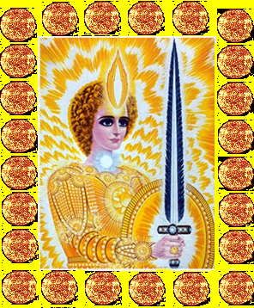
Zadquiel Jerarquia Violeta Mikael Solar Antakarana
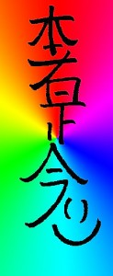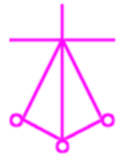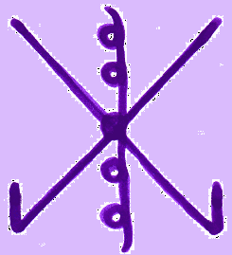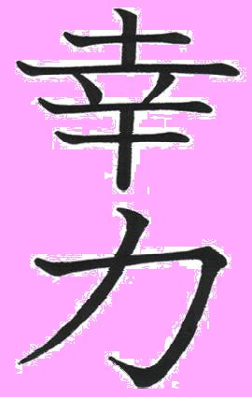
Hon-Sha-Ze-Sho-Nen Karuna_harth Rama Koriki felicidad

1) Love with the Goddess Aphrodite, Eros and Archangel Chamuel.
2) Wealth, Goddess of fortune Lashmi, The God Ganesha and Goddess removes obstacle Saraswari, gives Wisdom.
3) Health Physicians of heaven and the archangel Raphael, for healing.
4) Violet Fire, eliminates bad energies in place and people, spiritual ills.
5) Sol vitality, to vitalize people or group of people.
6) Sun transmuting, vitalizes and eliminates bad energies, bad influences.
7) San Miguel Archangel, free from all evil spiritual dangers pound.
8) Lord Ganesha for success Luck, development of prudence and unlocking paths.
9) Archangel Zadkiel, eliminates bad energies in place and people, spiritual ills.
10) Hierarchy Violet, transmutation, removing bad energy.
11) Mikael Solar, backed San Miguel del Sol
12) Antakara. Healing.

There are more pictures, Reiki, which are widely used, see Manual Reiki.

13) Hon-Sha-Ze-Sho-Nen, healing.
14) Karuna_harth, Cura heart and relationships.
15) Rama, unlocking.
16) Koriki, happiness.

Other images more.
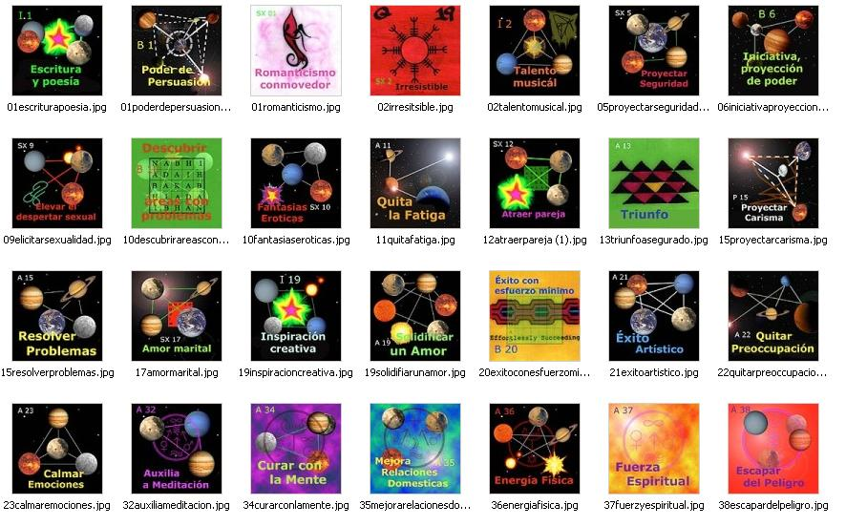

Opening get this.
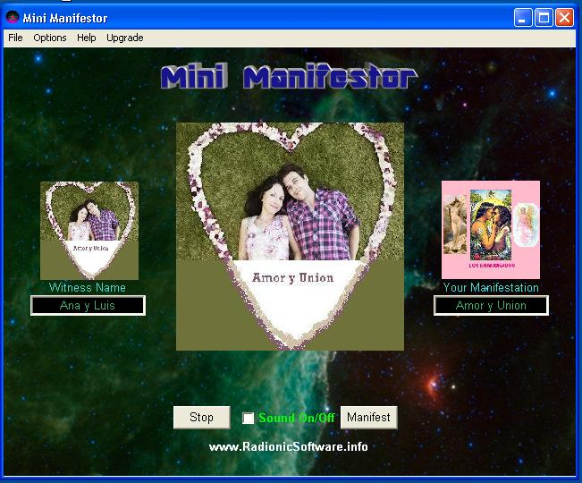
Where it says, winess Name, place the name of the person, only gives to write a short space, as the example: Ana and Luis. He writes in Your Manifestation, manifestation, what you want to manifest. In this case, Love and Union.
Sound, is to place solar sound can be On / Off.
All set.
To activate the program, press the icon, Manifest.
If you want to stop the program, press Stop.
Some recorded apart an affirmation of what they want and place it in your Windows Media Player, on repeat, on low volume. While the program works. The repetitive statement also has the power to manifest in reality, physically.
On some computers, after a while, you put the monitor in black, or activates the screen saver.
In this case not run the Windows Media Player, with an audio or video and put it on auto-repeat. This will, the computer will remain with the active monitor. And it minimizes this player. And unfold on screen Manifestor program.
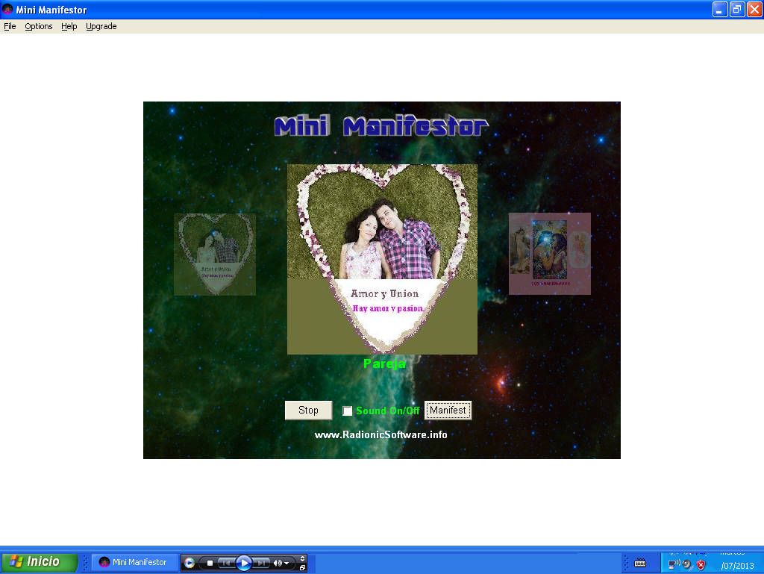
The power of this program is its projection on the monitor. Hence the creation out into space, producing the desired effects.
Also another way that the monitor is turned off, as it will go to the Control Panel and then click Properties Power Options.

The Mini Manifestor in action.
Something else for audio or sound.
Statements that can be recorded and place, instead of ringing Solar and automatic repeat it on Windows Media Player. While the program works. It gets a low volume.
If you want to influence other people, with the same message, you need to record an audio message for everyone, concentrate each message in each person. Never use the same audio message to another person, other than the one you concentrated, when you recorded it.
Example:
Love
If it can be painted, photo, drawing, a romantic scene and statements appropriate to what you want.
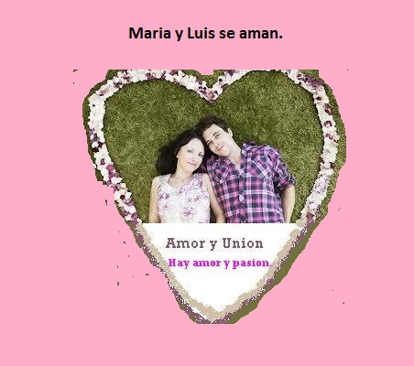
You can write above and below the photo or drawing of the couple siquiente:
Example:
There is love, desire and unity among us.
There is forgiveness and understanding.
We love you and there is harmony.
There is peace love and understanding.
So and so, love me and loves me dearly.
So and so is crazy in love and desire for me.
You can also do similar recording.
Image is used as a demonstration of love that follows.
Love
Here is present, the goddess Venus or Aphrodite, the Archangel of Love, Chamel and image lovers.
Winess Name, the name of house partner, Example Cristina and Jose.
Your Manifestation, Example: Love and passion.

Remember influence not dominate. The program itself influences, but depends on the free will of the individual.
Well, that situation commented, suddenly, you notice a change inside to a person, after a dream, or after a minor event, usually due to a love spell or some form of mind control at a distance (the traditional way where you have to sit / to concentrate on a chair / a long time in the woman / man you love and send love suggestions).
This is also the way it works, influenced the person feels something, and this feeling comes from the subconscious mind, and begins with a change of mind towards you, and with continued use of the program, this change of mind and the attraction of suddenly to you, gradually gives way to love, to a point where you can not live without you.
In some cases it happens, and there must be a minimum chemistry and some affection for there to be.
Health:
In the picture of the patient is written above and below this.
The Court Medica spiritual heal Luis Martinez, Liver and any other health problem.
Winess Name, Name of witness in this case Luis Martinez.
Your Manifestation, manifestation, healing.
This image is used with the doctors of the sky.
Are the archangel Raphael, Hippocrates, Paracelsus, Dr. José Gregorio Hernández, Dr. Jose Maria Vargas and Dr. Luis Razetti.
Court Medica

Wealth.
You can put a photo of people and business and up and down you can put written this or similar.
Sri Lashmi, Sri Ganesha and Sri Saraswati, give prosperity and fortune.
Diosa Lashmi, Ganesha y Saraswati.
Lashmi, thrives, Ganesha unlocks and opens paths to success and prosperity and Saraswati, Wisdom gives adequate to handle in life.
Winess Name, name of person, group or business.
Your Manifestation, Prosperity or wealth.

Spiritual cleansing or release of evils.
In winess Name, is to name people, example: Cristina and Antonio.
In Your manifestation, we can write, cleaning, or purification, liberation evils.
These can be used alternatively. All are very effective.
The Archangel of purple or violet fire calls. San Miguel

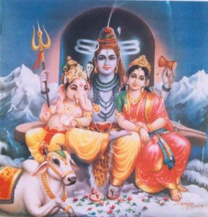
Violet Sun Dios Shiva, Parvati y Ganesha

IMPORTANT NOTE: The program Manifestor Nini influences on the person, not dominate. There case that one but want, is not given.

1) Sometimes you want to be loved and the other person, in any form you want the other person, you can not govern in their feelings.
2) If reconciliation, partners, friends, and because the offense is so great that the person does not forgive.
3) There is psychological behavioral problems, unsteady. You can not maintain a harmonious relationship.
4) There are problems, negative energy load, which blocks and damages the person's conduct in relation to others. In this case should be cleaned with violet fire.
5) There are second persons, whether another person who loves or cares.
6) There is interference from people who damage relationships, whether friendship or love.
7) There may be spiritual evils, who do you have an attitude opposite to what it should be. In this case should be cleaned with violet fire.
8) In the case of health, as in other cases help with medical court gives healing. But should this be accompanied by adequate food. Herbal remedies for the disease in question. Remove soda, especially Pepsi and Colacola. You contain many ingredients harmful to the greeting as phosphoric acid, very harmful substance such as bone and cartilage system, not to mention more general damages. Should Rosemary tea drinking, which is anti bacterial, antioxidant, helps the liver and the whole organism to its healing and Cat's Claw, excellent for many things.

Romero. Benefits.
It is a stimulant and tonic *; promotes recovery in respiratory diseases and digestive system helps to overcome liver disorders. Taken in tea after meals helps digestion and prevents the onset of symptoms of poor digestion such as bloating, flatulence, heartburn, etc.. / * Emmenagogue * /: Reduction slightly pains of menstruation and facilitates emptying, preventing colateres problems originating as headaches, stomach, fluid retention and general irritability. (Infusion of a spoonful of flowering tops. 2 cups daily) * Anemia *: contains a lot of iron that can help overcome the lack of it in our body in cases of anemia.
Is a plant with more antioxidants. Very rich in rosmarinic acid, myrcene and camphene with antioxidant properties. These properties may be useful in treating diseases like cancer, AIDS. or Alzheimer's.
* Sexually transmitted diseases: Its antibacterial properties can help supplement antibiotic treatment in sexually transmitted diseases such as gonorrhea.
Uncaria tomentosa or Cat's Claw.
Benefits.
Discovery by modern medicine, cat's claw (Cat's Claw) is applied to solve the following problems:
• Dolores by rheumatism.
• HIV or AIDS Immunodeficiency
• Standardization of some immune system functions.
• In cases of infections of all kinds
• Ulcers and tumors.
• Blood clotting.
• In degenerative diseases such as cancer (female genital tract, lung and gastric bronco) and tumors.
• viral processes.
• Irregularities of the menstrual cycle.
• Gonorrhea.
• General weakness and convalescence.
• Diabetes.
• Deep Wounds.
• hemorrhoids and fistulas.

